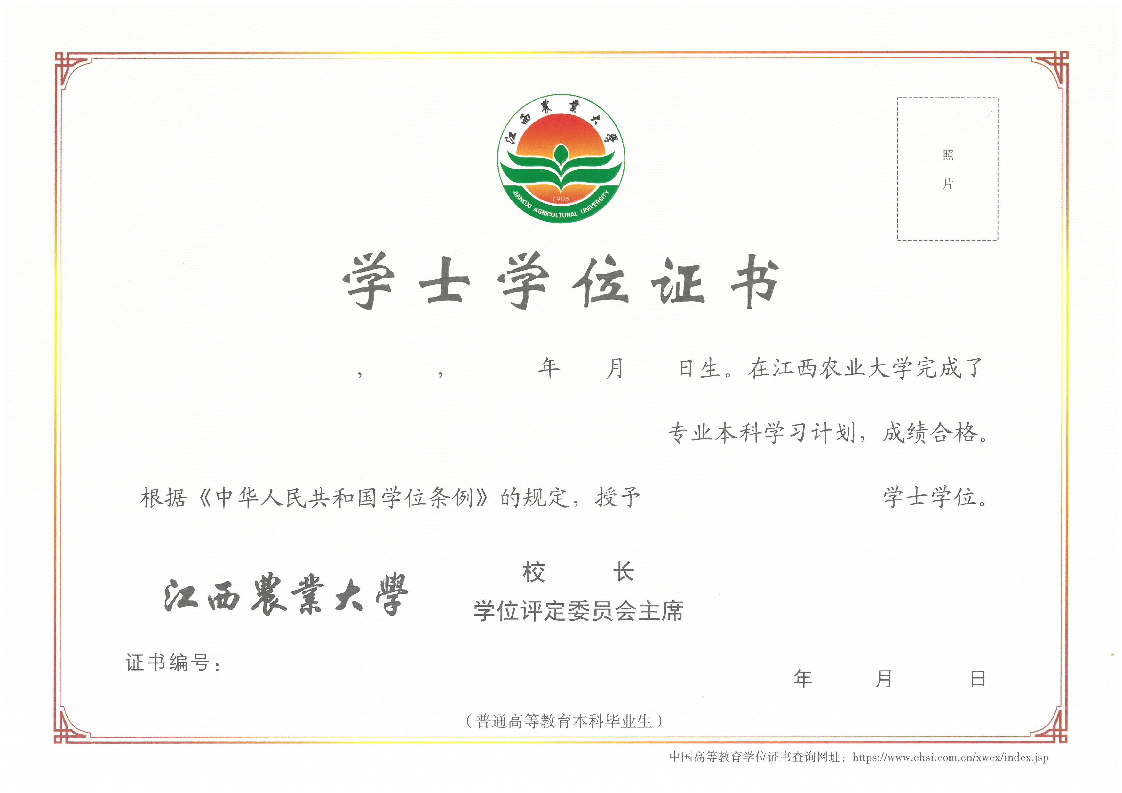

JIANGXI AGRICULTURAL UNIVERSITY

Certificate of Bachelor’s Degree
This is to certify that Mr/Ms 申请人姓名， who was born on 申请人生日, majored in 专业名称 at Jiangxi Agricultural University. After having fulfilled all the requirements of undergraduate coursework, he/she is awarded a Bachelor’s degree of 学士学位类别 in conformity with the Regulations Concerning the Academic Degrees of the People’s Republic of China.

（申请人注意：
1、空白证书图像应替换为申请人的证书图片；
- 模板内蓝色文本内容替换为申请人的个人学历信息；
- 学位证书图片和上下文需要对照，下划线是方便申请人修改本人信息时替换作用，在编辑英文翻译正文时要取消！！）

(学位评定委员会主席签字 的拼音)
Chairman, Degree Appraisal Committee of
Jiangxi Agricultural University
Certificate Number: 证书编号 Date: 证书颁发日期

