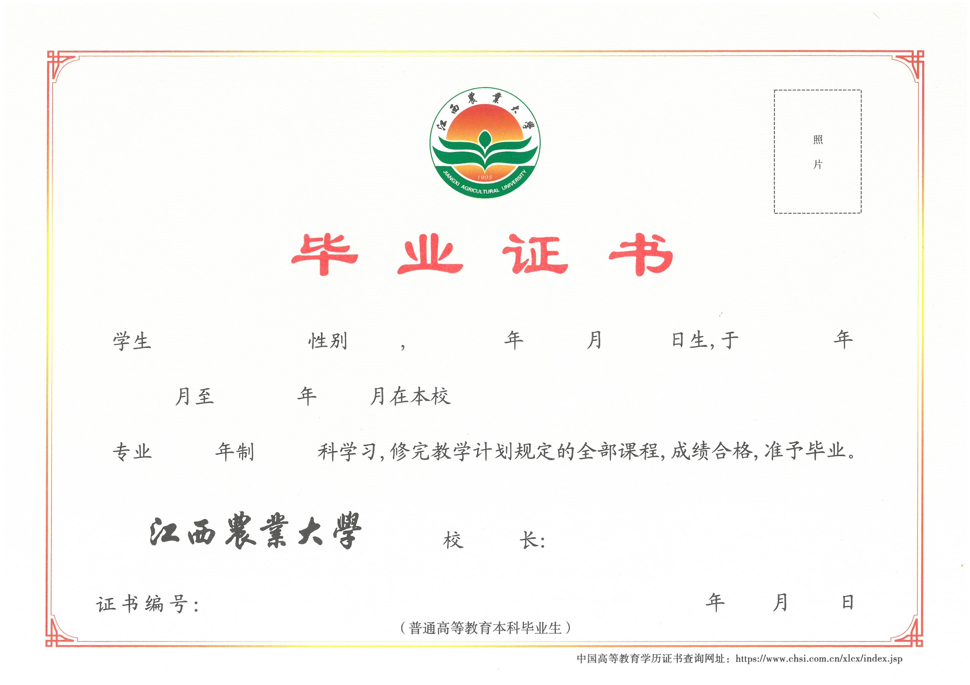

JIANGXI AGRICULTURAL UNIVERSITY

Certificate of Graduation
This is to certify that Mr/Ms 申请人姓名, who was born on 申请人生日, majored in 毕业专业名称 at Jiangxi Agricultural University from 入学年月 to 毕业年月. He/she is entitled to graduate after having passed all the required four-year undergraduate courses in conformity with the national educational plan.

（申请人注意：1、空白证书图像应替换为申请人的证书图片；
- 模板内蓝色文本内容替换为申请人的个人学历信息；
- 3、毕业证书图片和上下文需要对照，下划线是方便申请人修改本人信息时替换作用，在编辑英文翻译正文时要取消！！）

President：(校长签字的拼音)
Jiangxi Agricultural University

Certificate Number: 证书编号 Date: 证书颁发日期

